**Match and Color**

Match the words to the parts of the face. After, color all the parts of the face.

התאימו את המילים לחלקי הפנים וציבעו אותם.

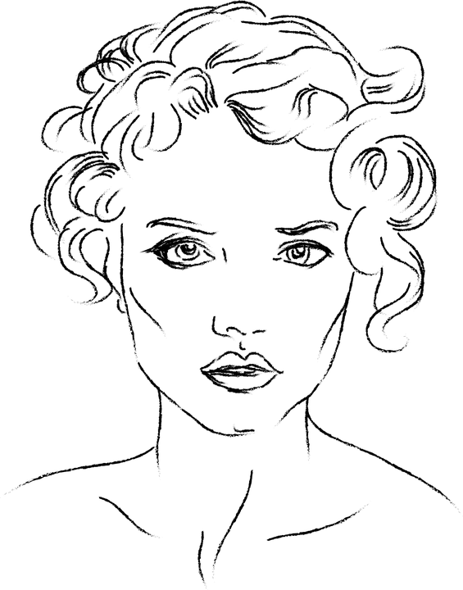

a

b

c

e

d

|  |  |  |
| --- | --- | --- |
| ear |  | 1. |
| eye |  | 2. |
| mouth |  | 3. |
| nose |  | 4. |
| hair |  | 5. |