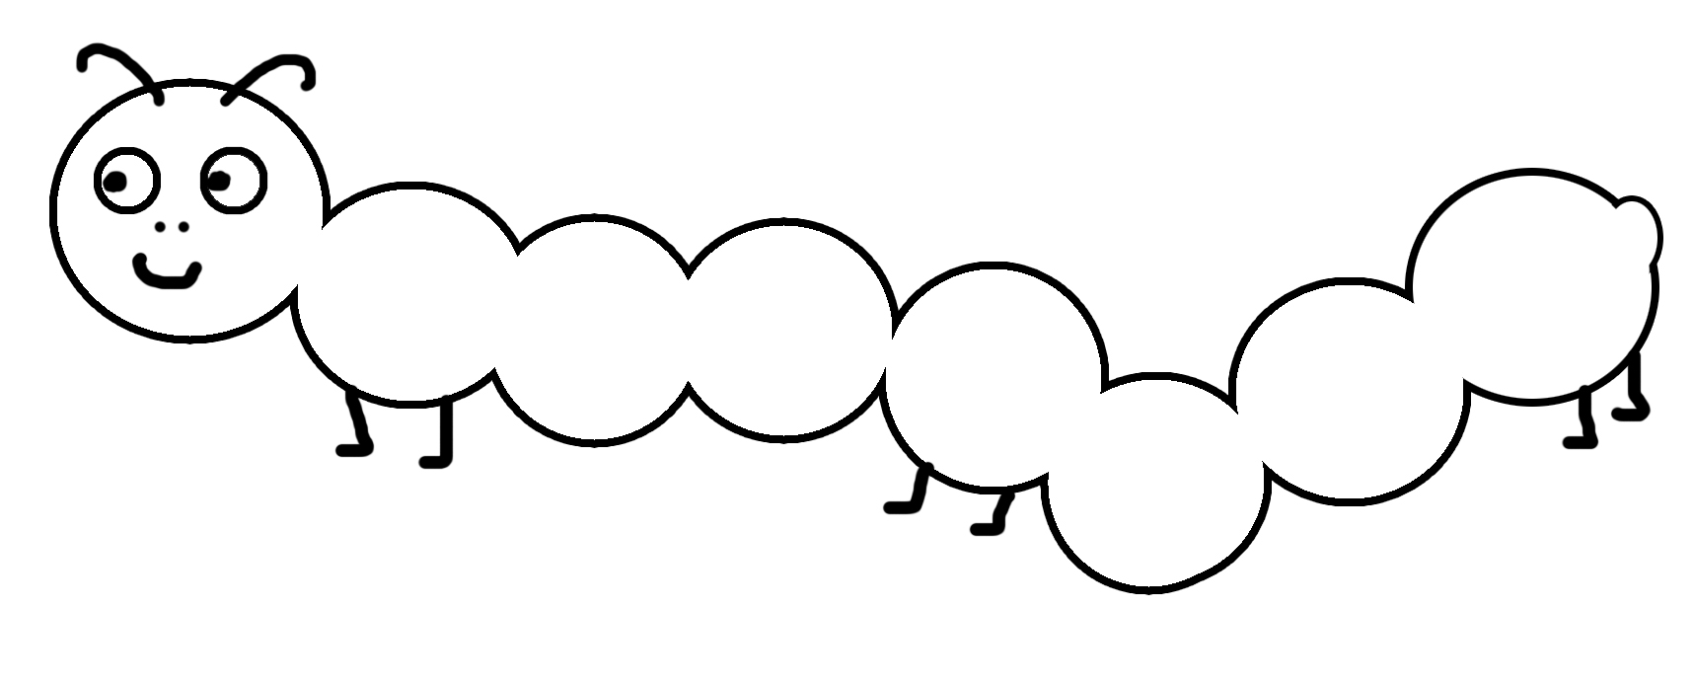  
  
**The Very Hungry Caterpillar**

* Cut out the circles and paste them in order on the caterpillar.
* גזרו את העיגולים והדביקו אותם על הזחל לפי הסדר



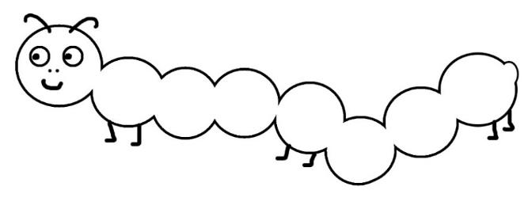 **What did the Very Hungry Caterpillar eat every day?**

* Paste the pictures of what the caterpillar ate every day.
* הדביקו את התמונות של המאכלים שהזחל אכל בכל יום בשבוע.

|  |  |  |  |  |  |
| --- | --- | --- | --- | --- | --- |
| Monday | Tuesday | Wednesday | Thursday | Friday | Saturday |
|  |  |  |  |  |  |

**Gherkin, Cucumber, Green, Garden, Growth, Vegetable  
  
  
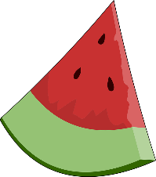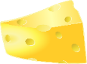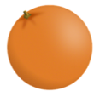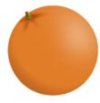**

* Cut out the pictures of what the caterpillar ate and paste on the other page.
* גזרו את התמונות של המאכלים שאכל הזחל והדביקו בטבלה בעמוד הקודם.

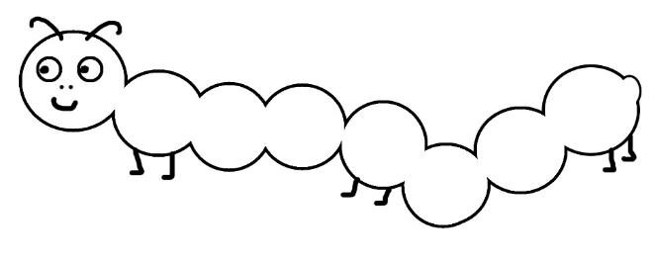 **What did the Very Hungry Caterpillar eat every day?**

* Write the words that tell what the caterpillar ate each day.
* כתבו בטבלה את מה אכל הזחל בכל יום בשבוע.

|  |  |  |  |  |  |
| --- | --- | --- | --- | --- | --- |
| Monday | Tuesday | Wednesday | Thursday | Friday | Saturday |
| Example:  one  apple |  |  |  |  |  |

**The Very Hungry Caterpillar** (Answer Key)

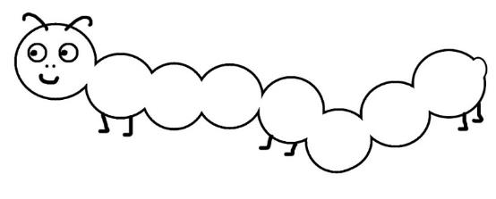 **What did the Very Hungry Caterpillar eat every day?**

|  |  |  |  |  |  |
| --- | --- | --- | --- | --- | --- |
| Monday | Tuesday | Wednesday | Thursday | Friday | Saturday |
| Apple, Nutrition, Healthy, Vitamins, Fruit, Garden | Fruit, Green, PearFruit, Green, Pear | Plum, Purple, Fruit, Fresh, Berry, Juicy, Ripe |  | Oranges, Citrus, Fruits, Food, Healthy, Fresh, JuicyOranges, Citrus, Fruits, Food, Healthy, Fresh, JuicyOranges, Citrus, Fruits, Food, Healthy, Fresh, JuicyOranges, Citrus, Fruits, Food, Healthy, Fresh, JuicyOranges, Citrus, Fruits, Food, Healthy, Fresh, Juicy | Ice, Ice Cream, Waffle, Dessert, Summer, SweetWatermelon, Melon, Seeds, Delicious, Eat, Food, FruitCupcake, Cake, Cherry, Stalk, Icing, FrostingDairy, Eat, Edible, Food, Swiss CheeseSausage, Links, Food, Meat, Beef, Cooked, GreasyAlphabet Word Images, Candy, Lollipop, LollyCake, Pie, Berries, Purple, Piece, Sweet, Food, SliceGherkin, Cucumber, Green, Garden, Growth, Vegetable |

(Answer Key)



**What did the Very Hungry Caterpillar eat every day?**(Answer Key)

|  |  |  |  |  |  |
| --- | --- | --- | --- | --- | --- |
| Monday | Tuesday | Wednesday | Thursday | Friday | Saturday |
| one apple | two pears | three plums | four strawberries | five oranges | one piece of chocolate cake, one ice-cream cone, one pickle, one slice of Swiss cheese, one slice of salami, one lollipop, one piece of cherry pie, one sausage, one cupcake, and one slice of watermelon. |